## 

horizontal line

**Mono Apartments - User Documentation v1.1**

17 May 2023

—

Prepared for Modern Nomads Group Pty Ltd

Yudo Baskaro, Director of the company

Team OneTen

# 

**1. Introduction 4**

1.1. Purpose 4

1.2. Scope 4

**2. System Features 4**

2.1. Credentials 4

2.2. User Journey Map 5

**3. General Features 5**

3.1. Login 5

3.1.1. Forgot Password 6

3.2. Update Profile 6

**4. Admin System 8**

4.1. Inspections 9

4.1.1. Inspection List 9

4.1.1.1. Sort by column 9

4.1.2. Add Inspection 9

4.1.3. Inspection View 11

4.1.3.1. Edit 11

4.1.3.2. Reject 11

4.1.3.3. Finished 12

4.1.3.4. Delete 12

4.1.4. Inspection Description 13

4.1.4.1. Download Functionality 13

4.1.4.2. Add Image 14

4.2. Apartments 14

4.2.1. Apartment List 14

4.2.2. Add Apartment 15

4.3. Apartment View 15

4.4. Users 15

4.4.1. User List 15

4.4.2. Add New User 16

4.5. Emails 16

4.5.1. View Email 17

4.6. Send an Email 18

5. Contractor System 19

5.1. Inspections 19

5.1.1. Viewing a Inspection request 19

5.1.2. Accepting an Inspection 20

5.2. Inspection Query 20

5.2.1. Viewing Rejected Inspections 21

5.5. Email 23

**6. C-Panel 24**

6.1. Email Account Management 24

6.1.1. cPanel login. 24

6.1.2. Username and Password 24

6.1.3. Email Accounts 24

6.1.4. Check email 25

6.2. System Back-up 26

6.2.1. Dasboard 26

6.2.2. System Backup choice 26

6.2.3. Backup 27

# 

# 

# Introduction

Mono Apartments is a real estate company located in Melbourne that offers a variety of rental properties in convenient locations throughout Melbourne. Their primary goal is to provide a simple and stress-free experience for clients looking to relocate or find a new home. The company employs local experts to help clients find the best possible housing arrangements based on their unique needs. Mono Apartments goes above and beyond by offering personalised services, such as advice on location, amenities, lease terms, and rental rates. Their commitment to excellent customer service and environmentally friendly building practices ensures a top-notch living experience for all tenants.

## Purpose

The user document is a set of instructions for the administrators at Mono Apartments on how to use a new system that helps manage property inspections for contractors. The document will explain how to perform different tasks, like scheduling inspections and assigning contractors, and it will outline the benefits of using the system, such as better organisation and communication. The user document will also include information about any requirements for using the system and provide troubleshooting tips in case any issues arise. The goal of the user document is to help administrators at Mono Apartments use the new system effectively and have a positive experience with it.

## Scope

The user documentation is a guide for Mono Apartments' administrators on how to use the new system for managing property inspections. It will cover how to schedule inspections, assign contractors, track progress, and generate reports. The document is for Mono Apartments' administrators and contractors who will use the system regularly, and will be available in electronic format with instructions, screenshots, and tips.

# System Features

## User Journey Map

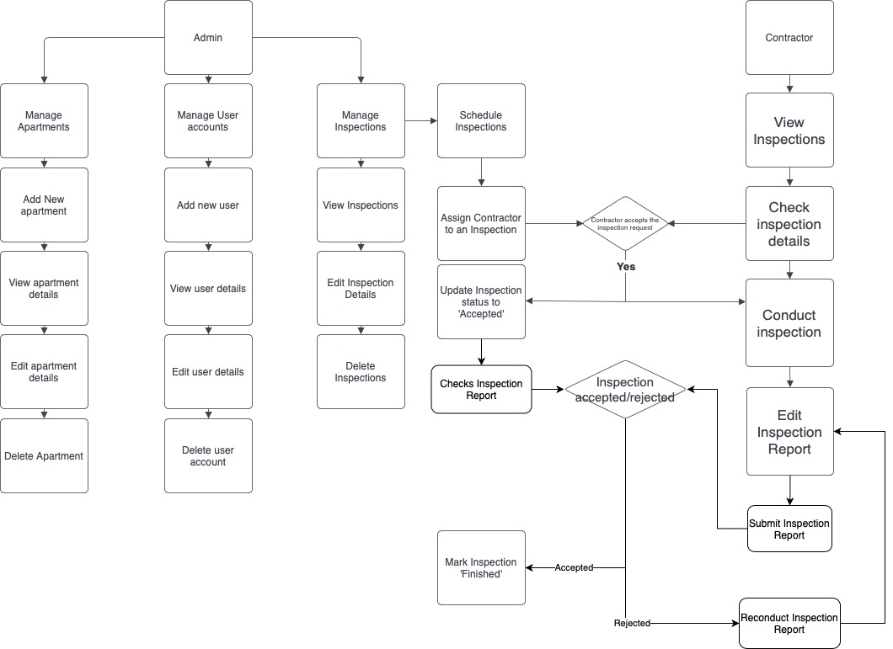

# General Features

## Login

When first entering the main page, scroll down to the team member login to login to the Mono Apartments system.

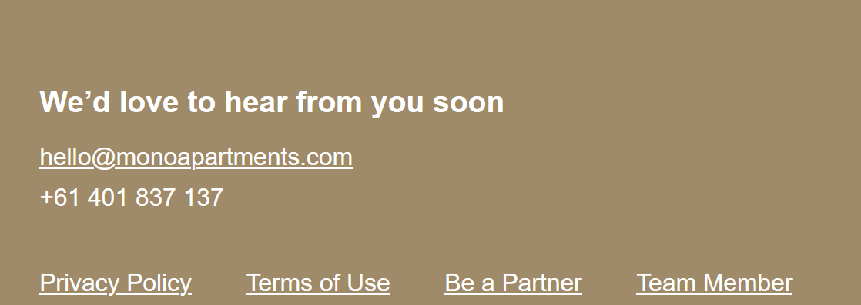  
  
 Fill in Login details.

For contractors, accounts need to be created by a Mono admin first to be able to access the system, as outlined in (Section 4.2.2.)

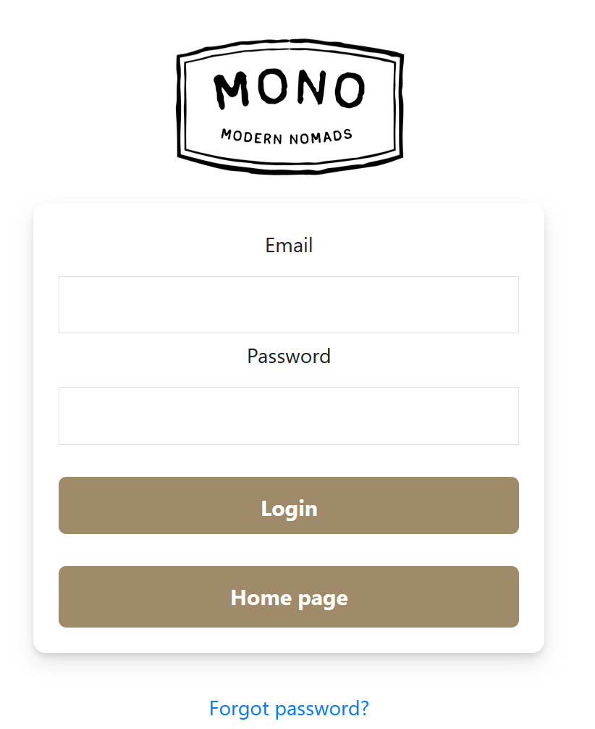

### Forgot Password

Press ‘Forgot Password’ and enter e-mail address in the specified field.  
  
 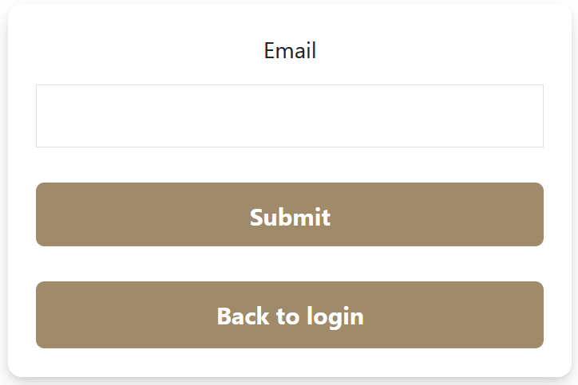

## Update Profile

Press the top right button, representing the user icon for the system, to be taken to a pop-out sidebar.

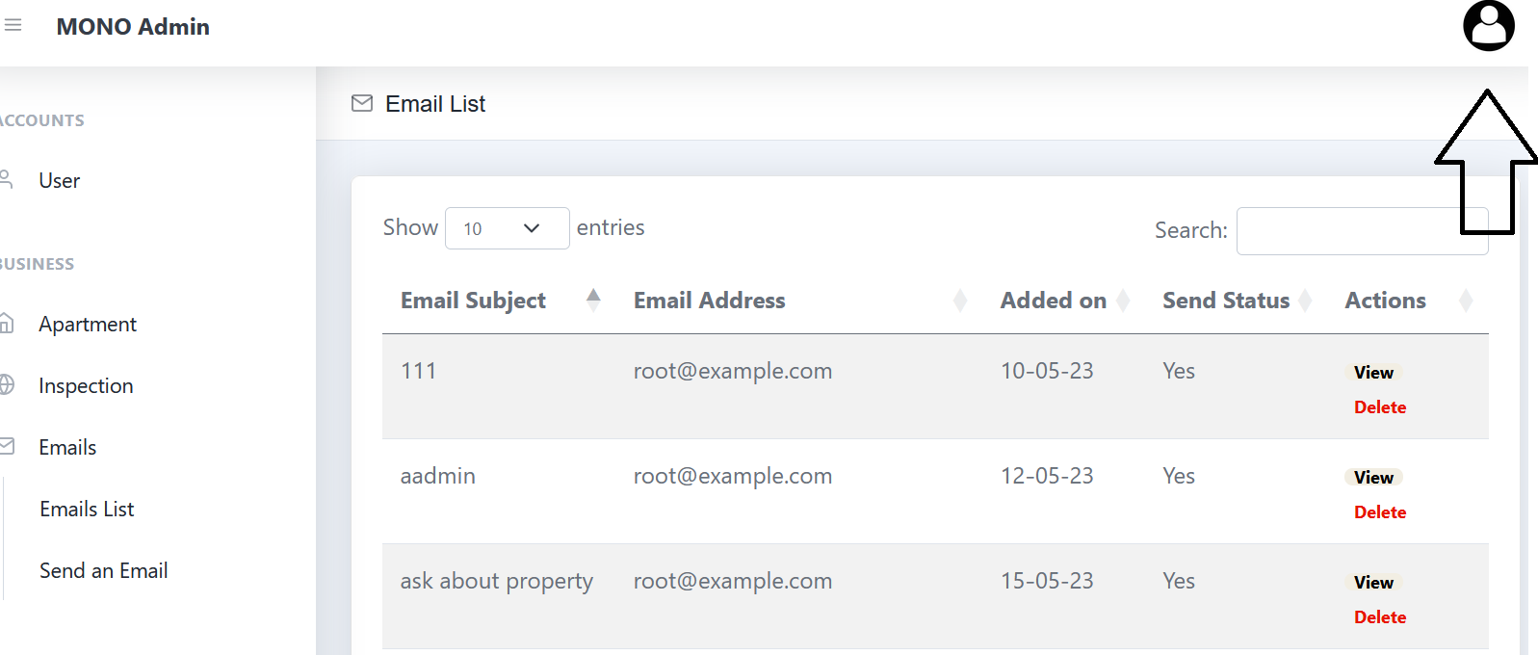

Press ‘Edit your profile’.

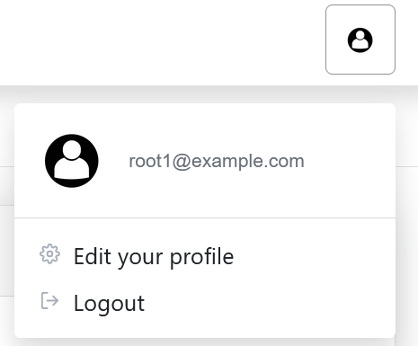

The user can then edit their profile, adding a profile image, or changing any of the fields after pressing the ‘Edit’ button.

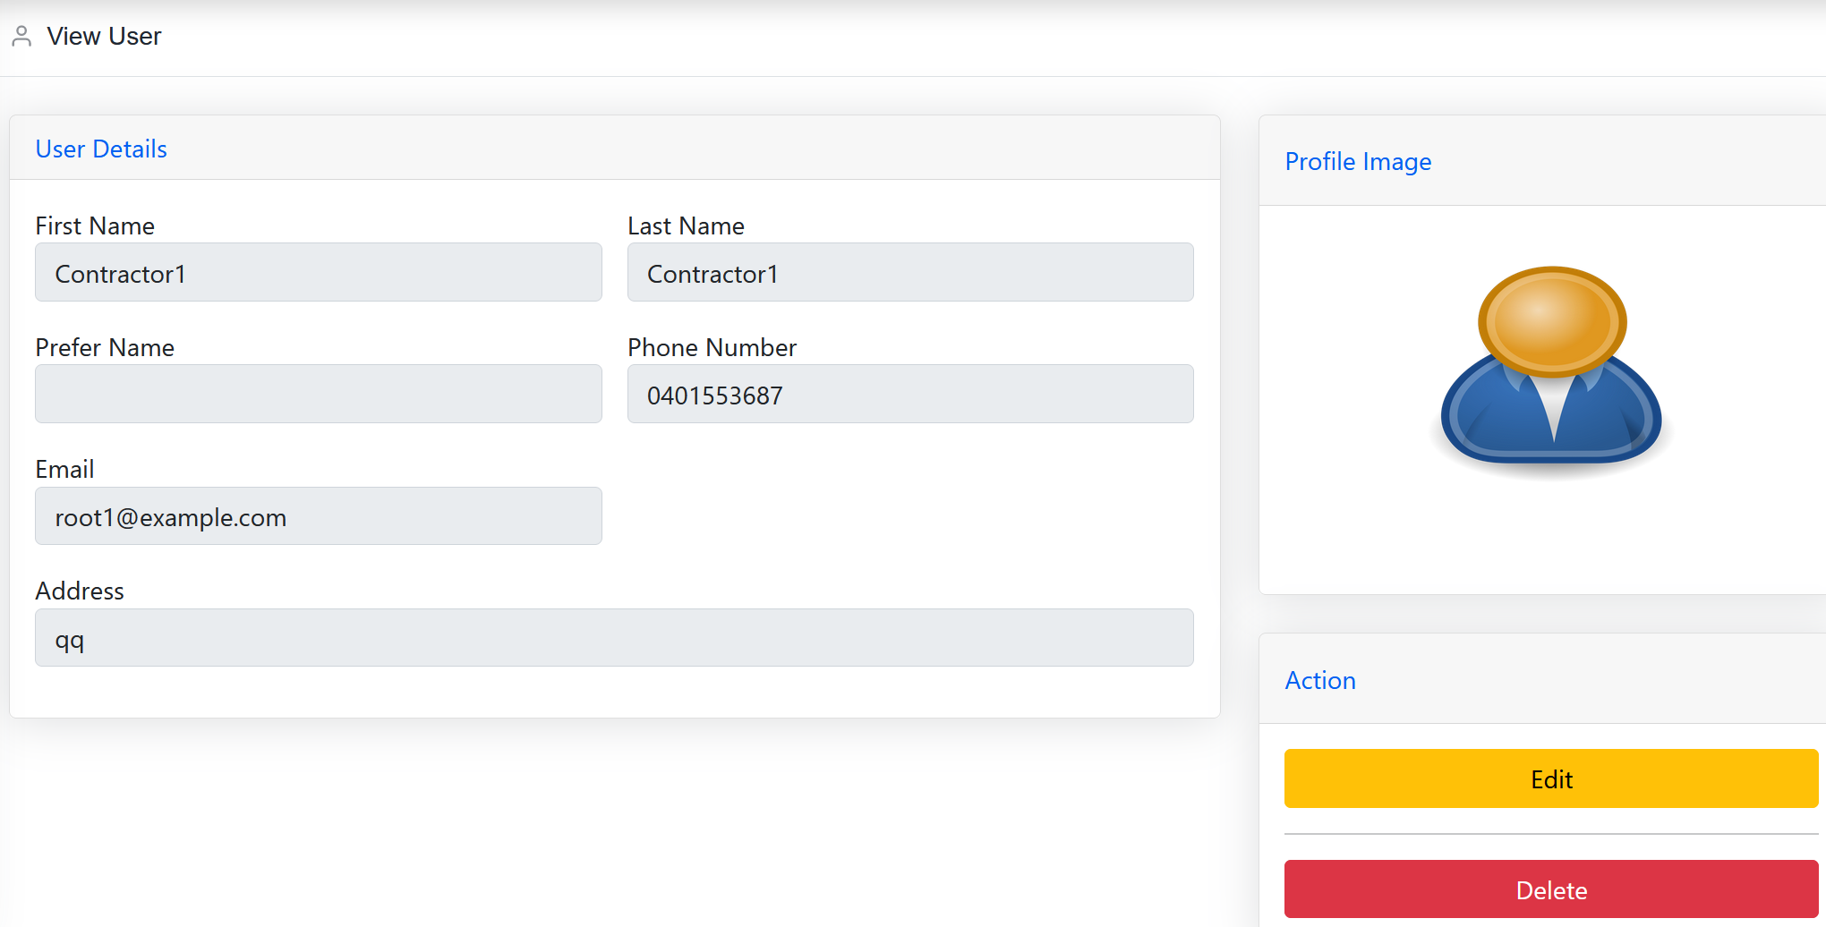

Once the user has made the changes, they can save changes by pressing the ‘Submit’ button.

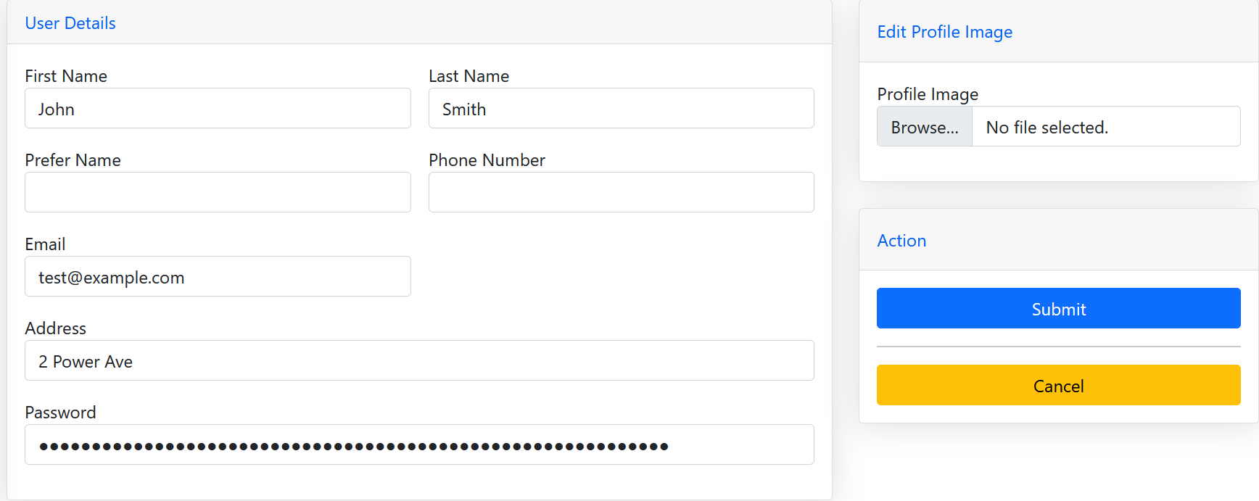

# 

# 

# Admin System

Representing the primary functionality for this project, the admin system provides the key working functionality. Allowing an administrator to manage the broader inspection process

## Inspections

### Inspection List

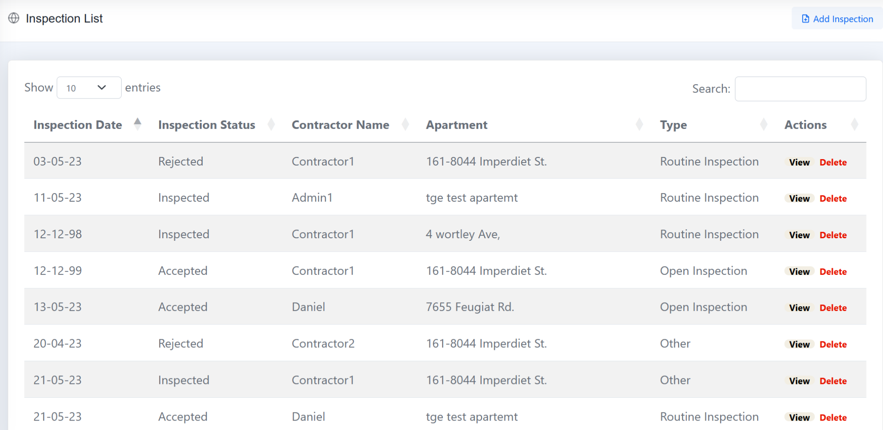

### Sort by column

Each column in the inspection list can be sorted by column.

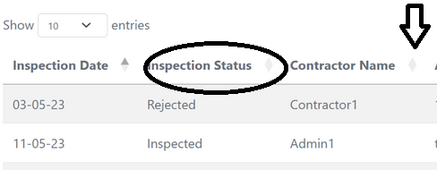

## Add Inspection



Pressing this functionality will create a new inspection, adding a new inspection to the inspection list. Creating basic inspection information to be entered for the inspection to be created.

Fields to be entered include:

* Apartment Address
* Inspection Date
* Inspection Status
* Inspection Type
* Inspection Description

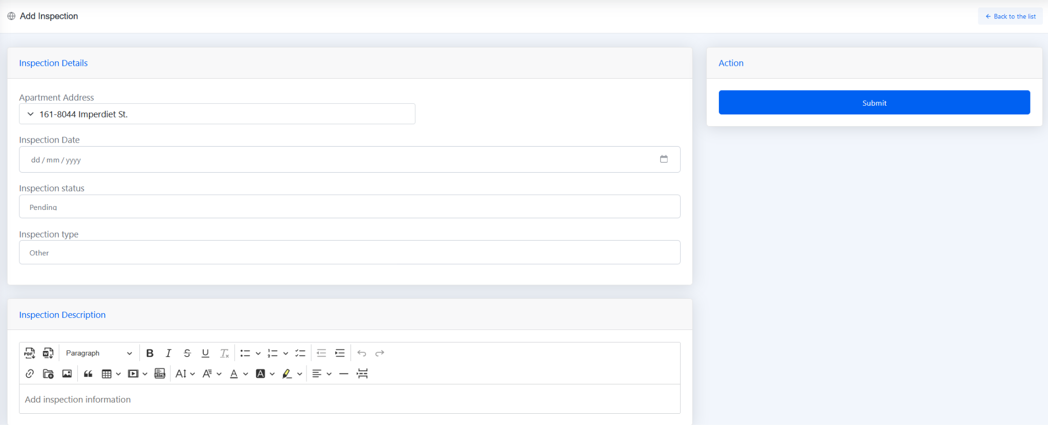

Inspection Description at this stage should include any vital information for a contractor to understand allowing them to choose to accept an inspection.

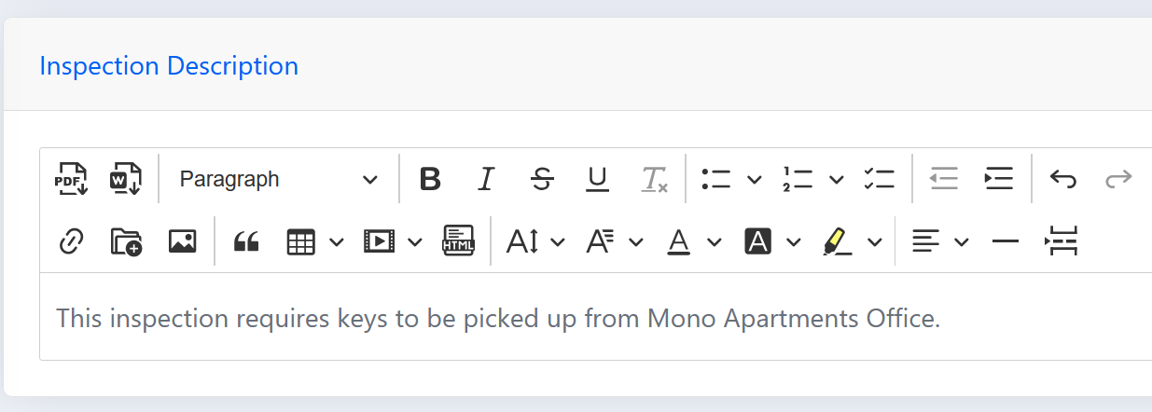

Pressing the submit button will create the inspection. This will be sent to all contractors.

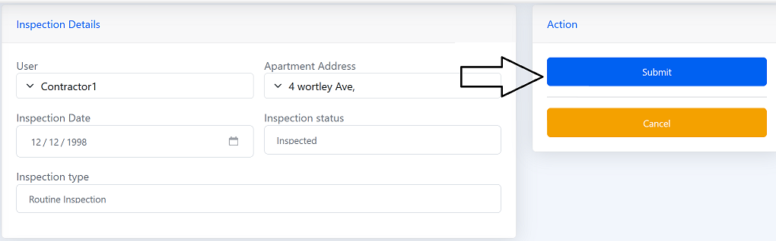

### Inspection View

Once an inspection has been created, the fields will be locked, awaiting for a contractor to accept the inspection.

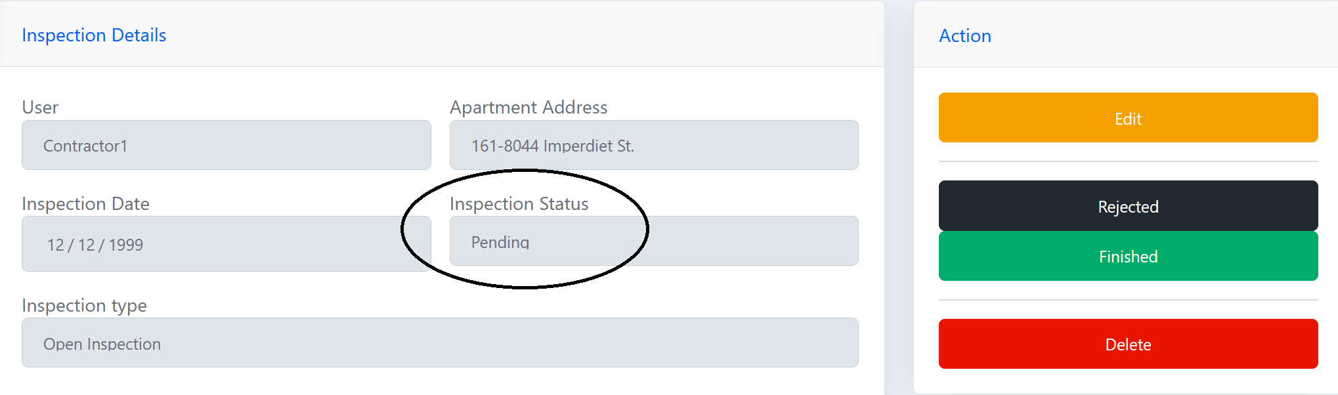

* Inspection Status
  + Pending: Inspection is awaiting action from contractors
  + Accepted: Inspection has been accepted by a contractor.
  + Rejected: Inspection has been rejected by Mono admin staff, awaiting further processes.
  + Inspected: Inspection has been completed by a contractor, awaiting admin approval.
  + Finished: All inspection processes have been completed.

#### Edit

This action is undertaken for contractors, allowing them to edit an inspection that they have assigned to them.

An admin can still edit the inspection if information needs to be changed, updated or removed. If they edit while a contractor is assigned to an inspection, the contractor will be notified of any changes(as outlined in section 3.3.).

#### Reject

Pressing the reject button allows an administrator to reject an inspection after reviewing the inspection form submitted by a contractor. This would be undertaken if the administrator believes the inspection form is insufficient or limited information has been submitted.

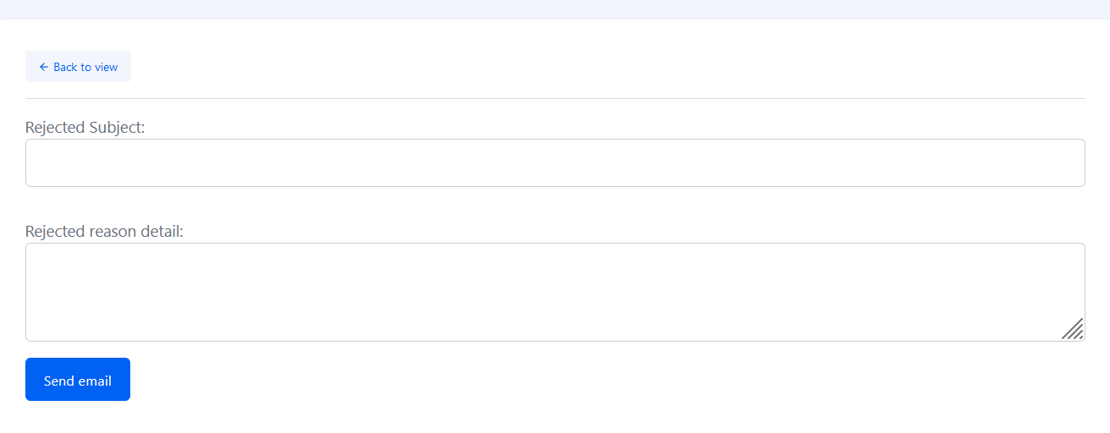

The administrator after pressing the reject button, will be directed to fill in rejection information. This information will be sent directly to the contractor assigned to the inspection, allowing them to understand why an inspection may have been rejected.

#### Finished

Noting the inspection as finished will show the inspection has been completed by the contractor and approved by the administrator.

#### Delete

When pressing the detele button, the admin will be prompted with a warning before they delete the inspection.

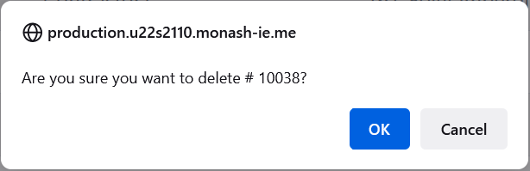

### Inspection Description

The inspection description contains key information relevant to the inspection and the process around the inspection form. This pertains to information that will be entered by the contractor while undertaking an inspection.

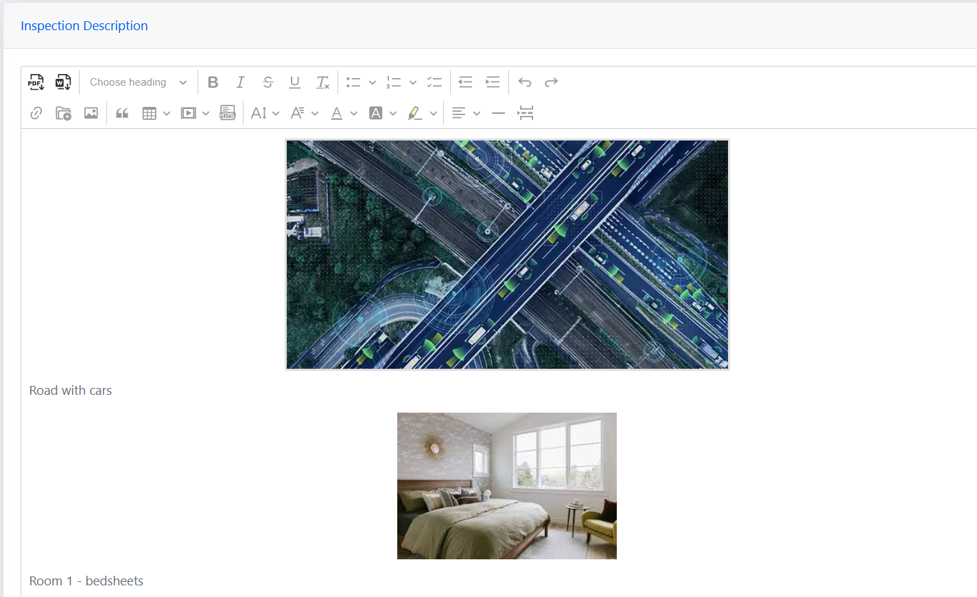

##### Download Functionality

This allows a contractor or an administrator to download the inspection form in PDF or .Docx format.

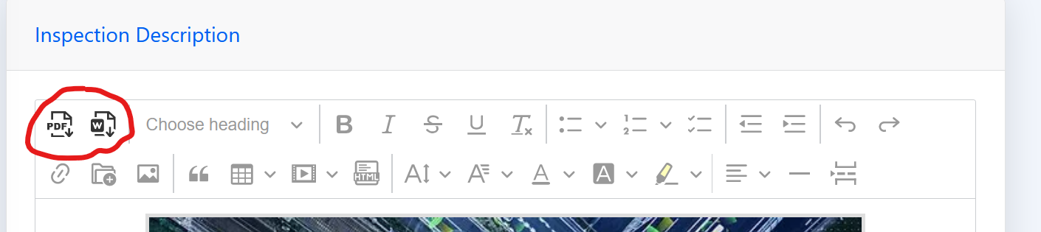

##### Add Image

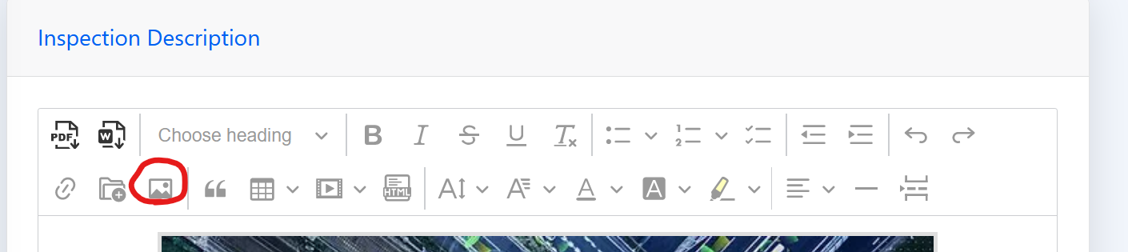

A key format of this inspection form is the image functionality, allowing the contractor to add images based around their inspection processes.

### Apartments

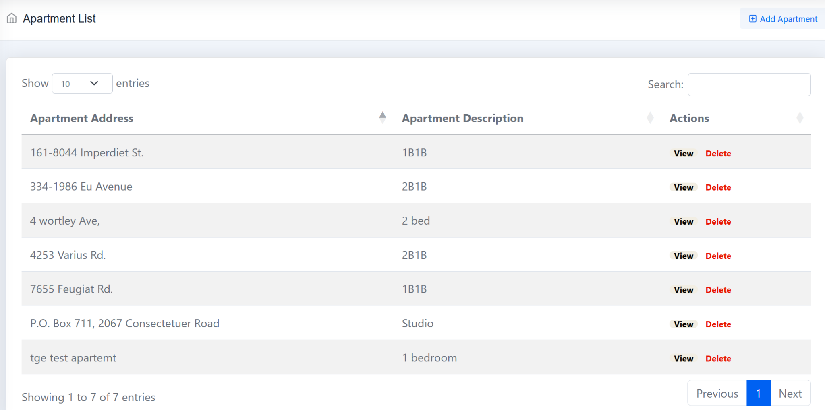

#### Apartment List

Contains information about each apartment including the apartment address and a brief description about the apartment, showcasing basic information such as how many bedrooms.

#### Add Apartment

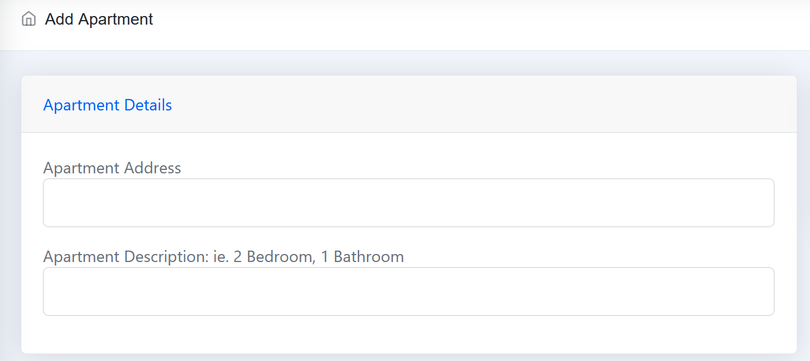

#### Apartment View

* + 1. Edit

This allows information of a property or apartment to be updated, if an address change is made, but more likely an Apartment description is updated if changes are made to a property

* + 1. Delete

An admin can delete an apartment by pressing the delete button, removing the records of the property from the apartment list.

### Users

This functionality allows an Admin to manage users and will provide sufficient functionality to ensure contractors details are up to date, whilst also allowing the admin to add new users and delete old ones to ensure the systems security is protected.

#### User List

This list contains the list of users set up with accounts on the Mono system. This allows the admin to manage all users in the system, viewing user details, deleting old users or creating new users. To add a new user, the admin needs to press the ‘Add User’ button and will be taken to the next page.

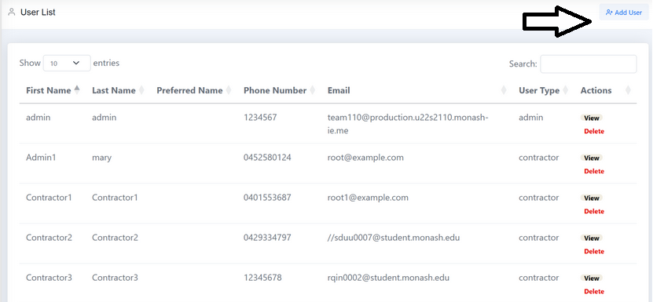

#### Add New User

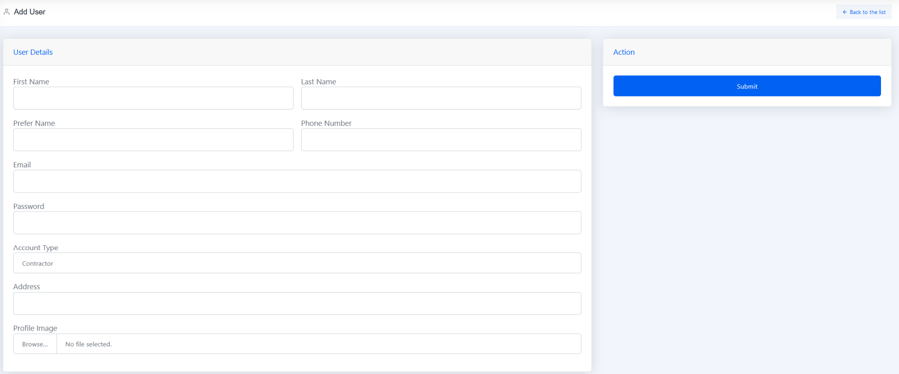

This information includes fields that need to be entered to add a new user.

Information Includes Name details, phone number which is useful for an admin if they need to contact a contractor outside the system.

Email is very important to be entered correctly, as the contractor will receive system notifications through their personal email account.

Passwords can be a password or passphrase, allowing up to 25 characters to be entered. Users of the system need to ensure they use harder to guess passwords, ideally passwords from a password manager that can be created as complex longer passwords or passphrases which are harder to be cracked, but easy to continue acting in business processes in a faster manner through the password manager.

### Emails

The email list holds all emails in the system, it can be sorted by each column, email’s can be viewed or deleted.

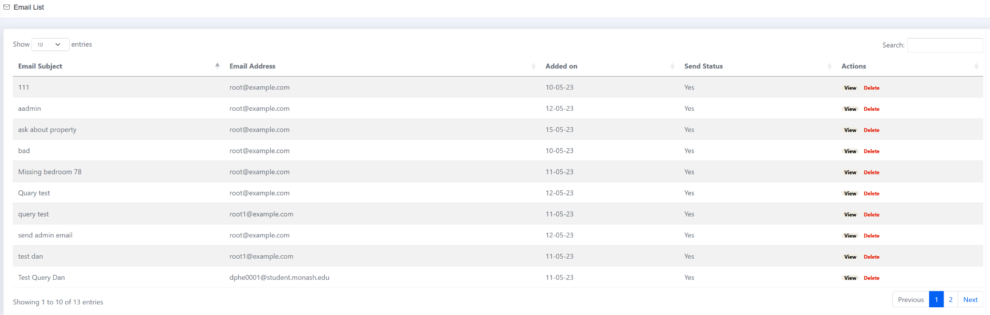

#### View Email

Viewing emails allows the admin to view email contents from emails present in the email list.

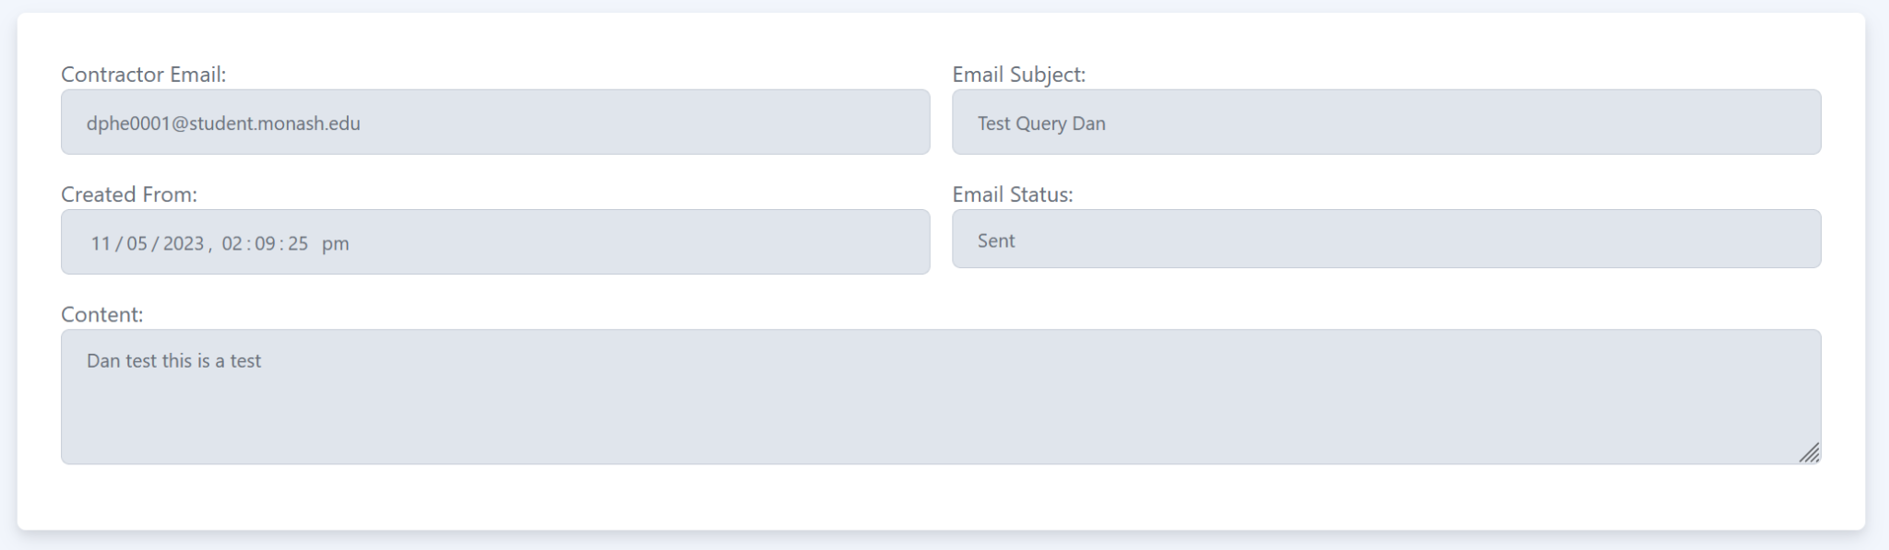

#### Send an Email

To send an email, the admin needs to press the send email button in the system sidebar.

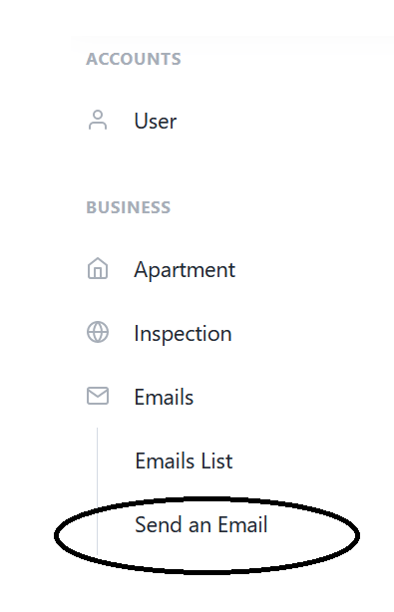

This will create an email template for the admin to enter email contents into. Including:

* Email Address of the Contractor
* Email Subject
* Email Text

This allows the admin to keep track of relevant inspection emails in the system.

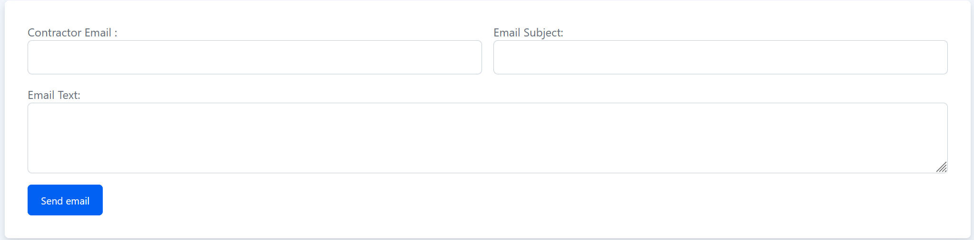

## Contractor System

### Inspections

The inspection list access for a contractor is limited to the inspections that have been accepted by a contractor.

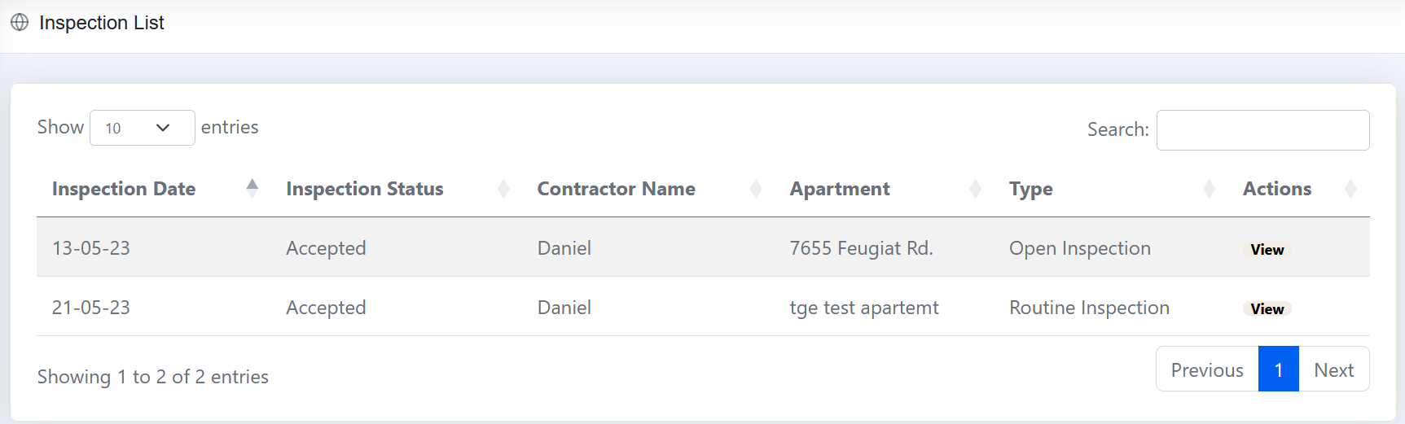

#### Viewing a Inspection request

This enables a contractor to view an inspection that has been created by Mono admin staff. To proceed with viewing inspection details, the contractor can view the inspection or press accept if they are familiar with the type of inspection carried out at a property.

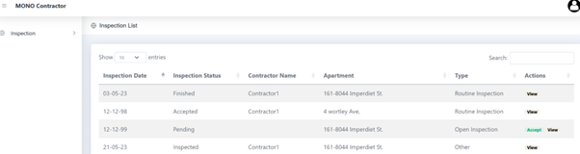

If the contractor presses the view button, they will be taken to view more details about the inspection that has been created. Here they can view the inspection description, which will be filled in by the admin providing extra information about the inspection such as how to contact the client, or where to pick up keys, or what information needs to be gathered in the inspection.

#### Accepting an Inspection

Once the contractor accepts an inspection, they will be provided with edit access to the inspection.

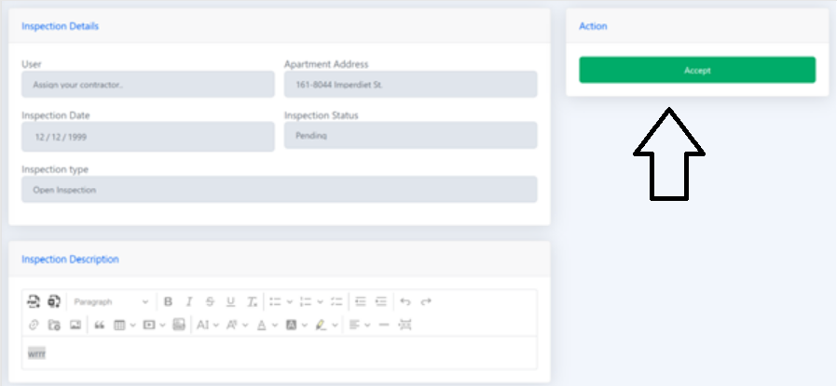

### Inspection Query

This functionality allows the inspector to submit a query in the same process as the inspection form.   
Pressing the send query button will take the user to a similar form as the email submission.

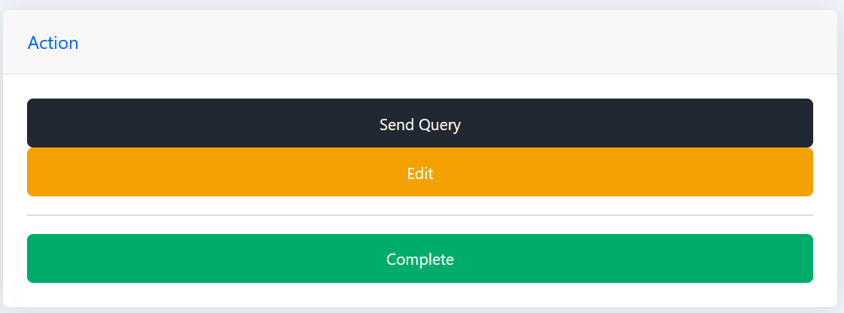

Sending this query/email will go directly to the mono apartments admin staff. This will allow the admin to view the query submission, directly related to the apartment the inspection is apart of, allowing them to view it as a smaller process rather than the email list, trying to sort which email the query is in itself and which inspection it is apart of.

The user needs to enter the fields for the subject - containing information about the inspection & question detail including what the query is.

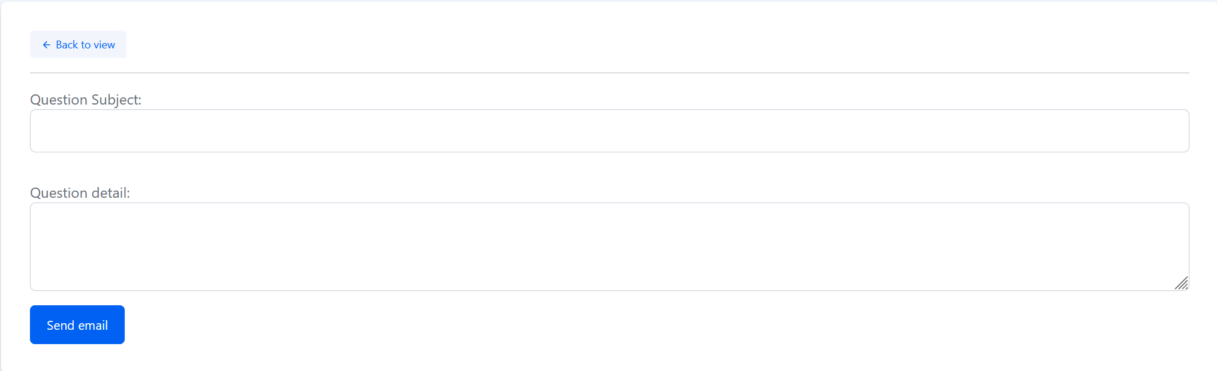

The administrator will receive an email directing them to the query and which inspection it has come from, as represented by the below image.

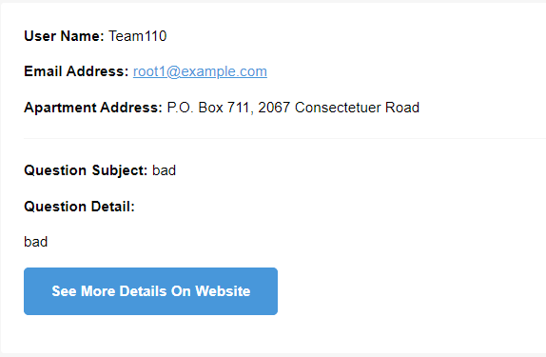

Pressing the ‘See More Details on Website’ button allows the administrator to view the query in the system.

#### Viewing Rejected Inspections

If an admin rejects an inspection, the contractor will receive an email, directing them to the website to view the inspection. They will also be provided with the admin’s reasons for rejecting the task.

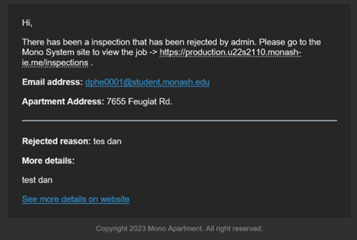

* 1. Admin Changes Notification

As outlined in the section 2.4.3.1, when the admin changes anything in the inspection page, while a contractor is assigned an inspection, the contractor will receive an email to their email address informing them of changes made.

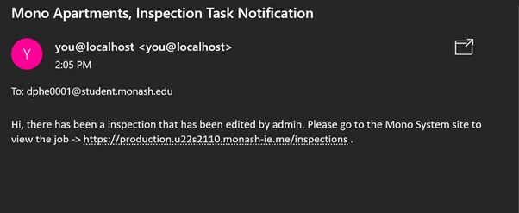

* 1. Submitting an Inspection form

Once the contractor has finished the inspection, they are able to submit the inspection form. This allows the administrator to view the completed inspection and follow up with the inspection.

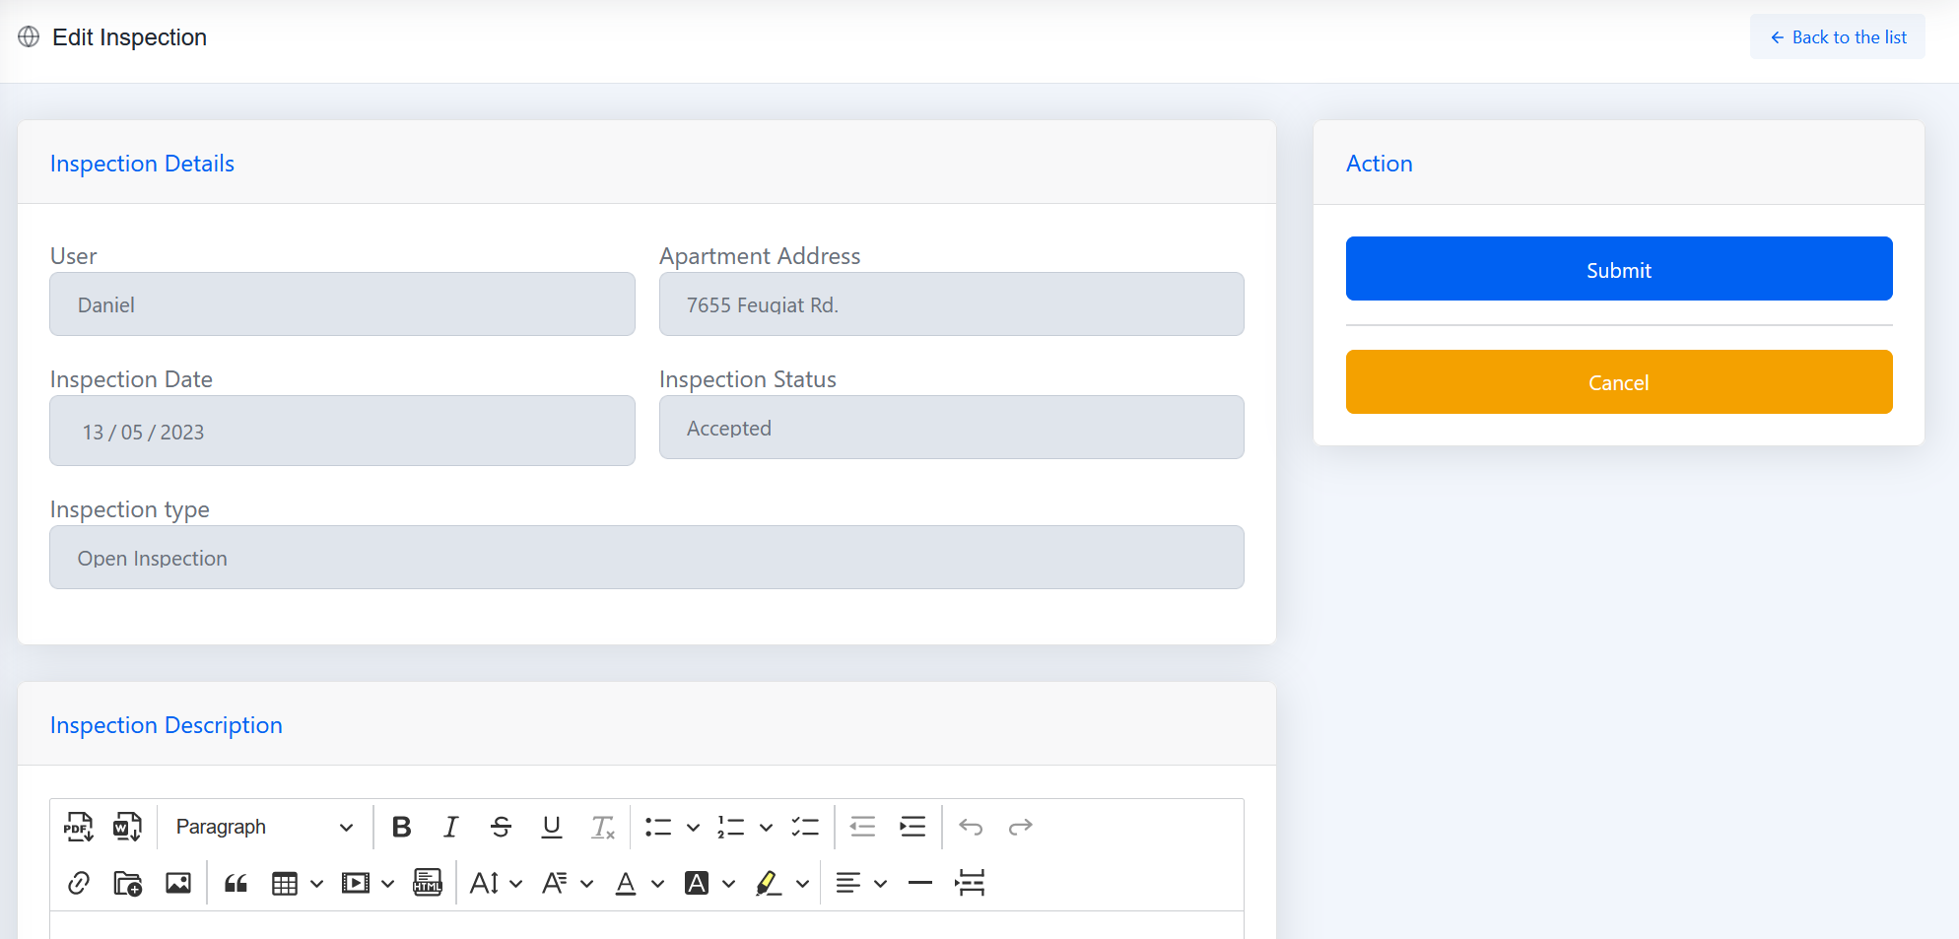

### Email

This functionality provides the contractor with the ability to send an email to the admin staff, if any issues need to be resolved, seamlessly in the system rather than in the contractor's email app.



 